Endpoint 1

* Test if working

* Test for 204 (No Content)

* Server Error (Error 500)

Endpoint 2

* Working Call

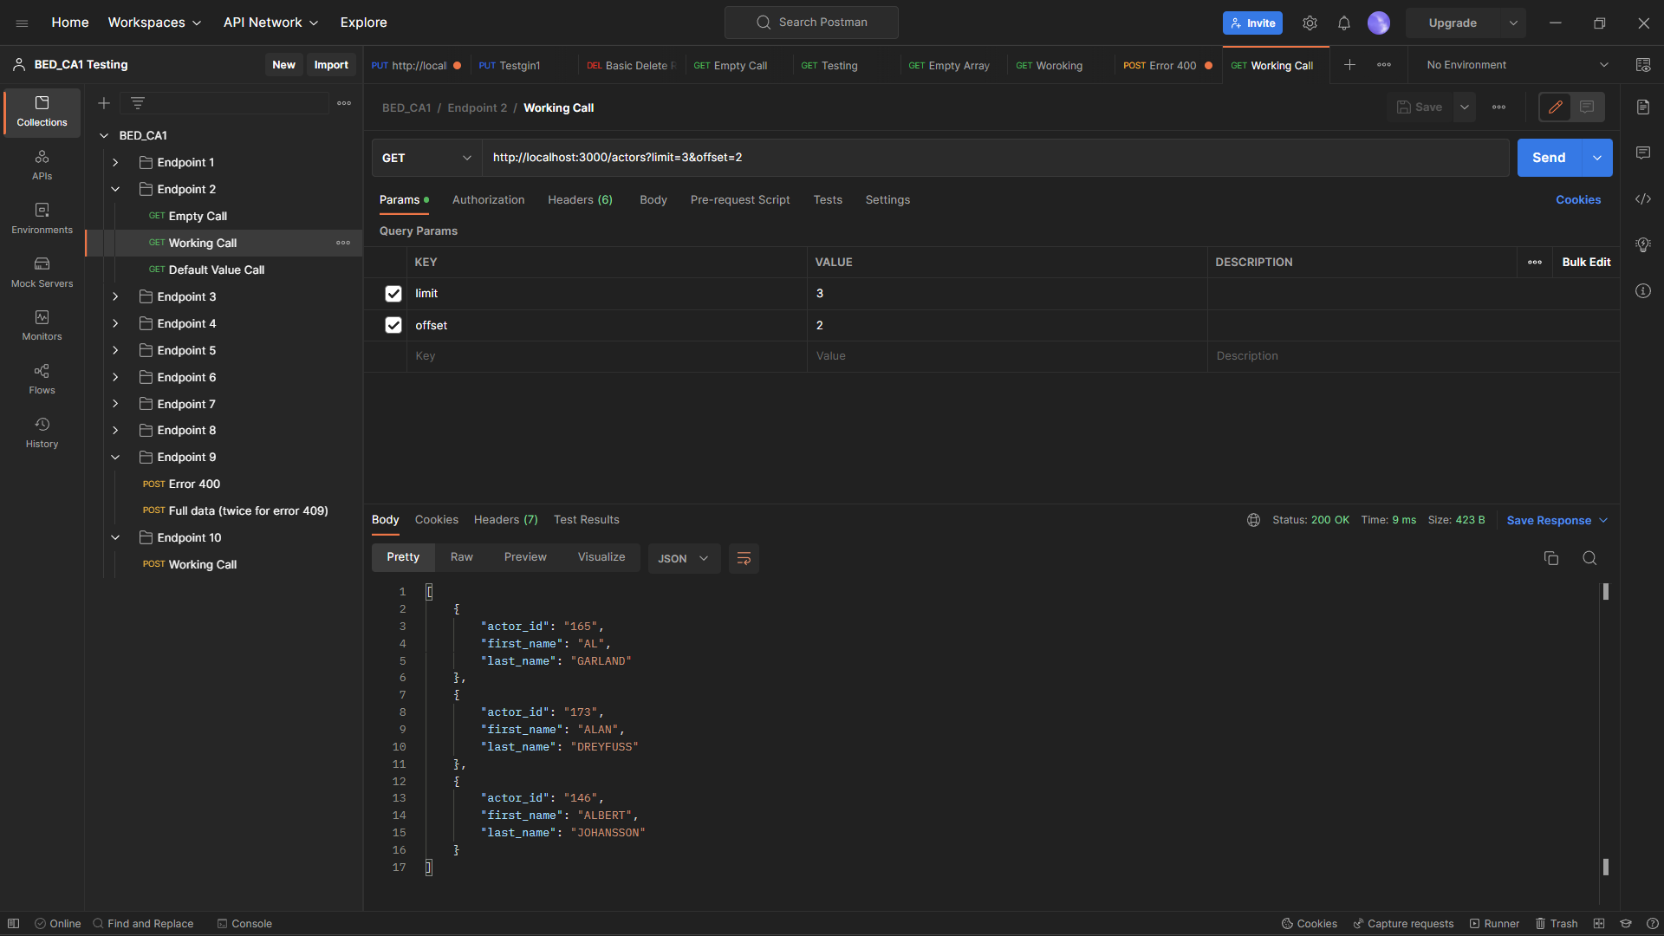

* Empty Call

* Default Value Call

* Server Error (Error 500)

Endpoint 3

* Working Call

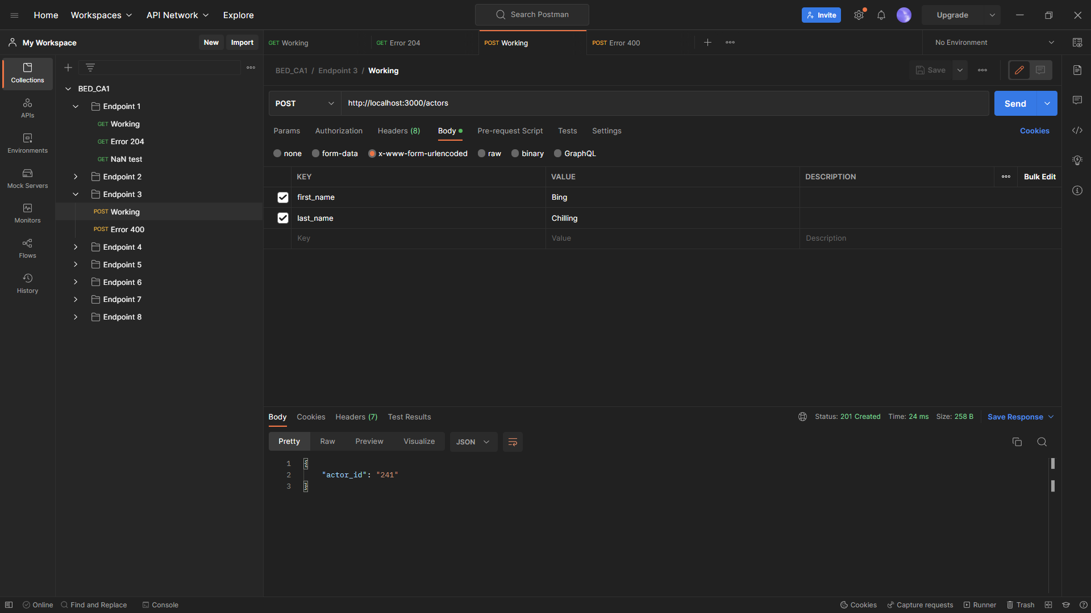

* Test for 400 (Bad Request)

- Server Error (Error 500)

Endpoint 4

* Working Call

* Missing Data (Error 400)

* No Actor ID (Error 204)

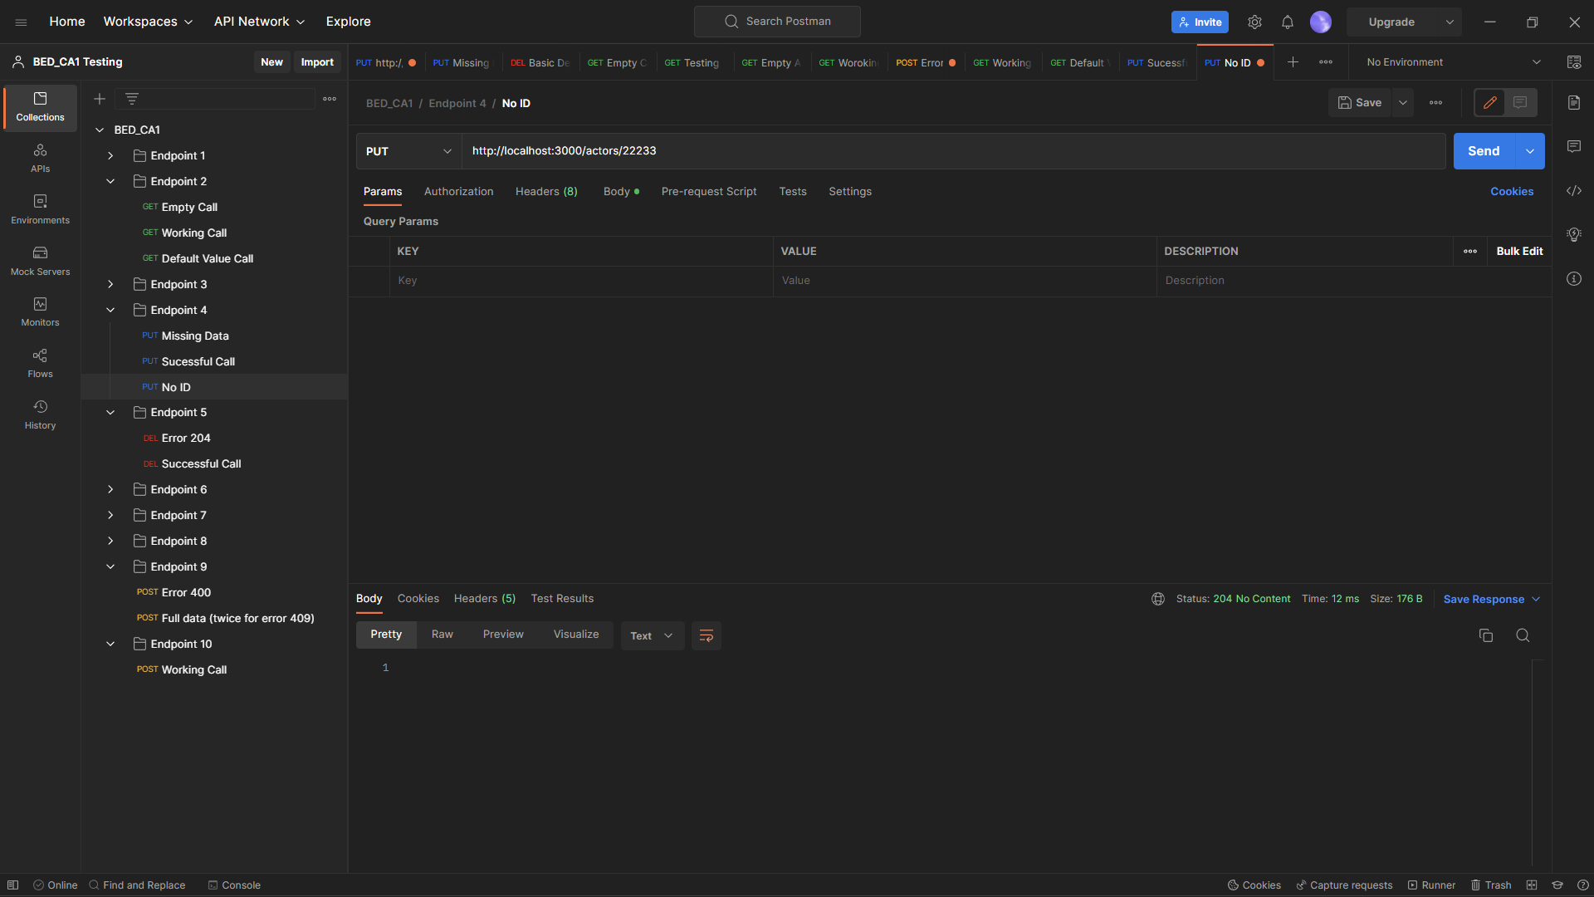

* Server Error (Code 500)

Endpoint 5

* No Actor ID (Error 204)

* Working Call

* Server Error (Code 500)A screenshot of a computer

  Description automatically generated with medium confidence

Endpoint 6

* Working Call

* No Category

* Server Error (Code 500)

Endpoint 7

* Working Call

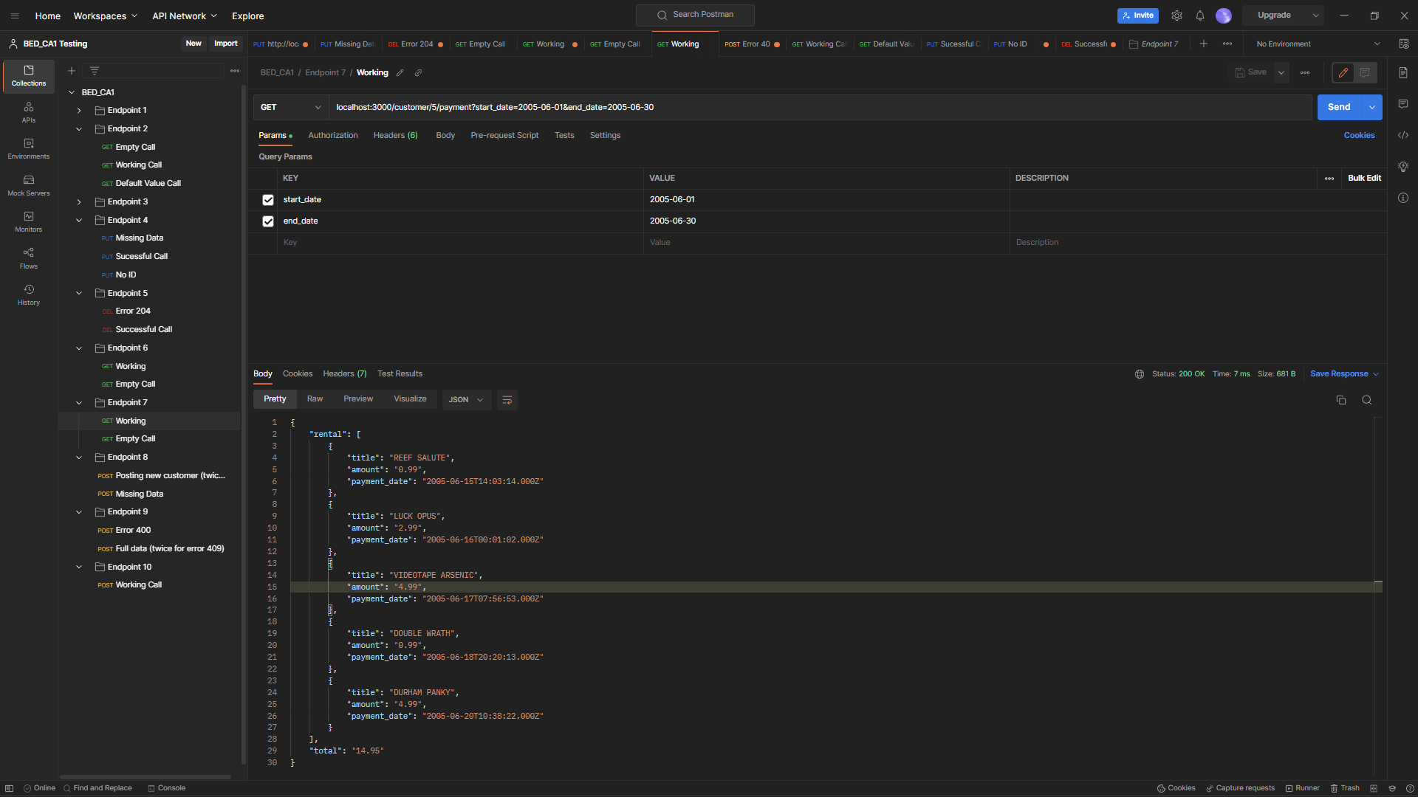

* Empty Call (no records for time period)

* Server Error (Code 500)

Endpoint 8

* Working Call

* Duplicate e-mail (Error 409)

* Missing Data (Error 400)

* Server Error (Code 500)

Endpoint 9

* Working Call

* Duplicate Location in system (Error 409) A screenshot of a computer

  Description automatically generated with medium confidence
* Missing Data (Error 400)

* Server Error (Code 500)

Endpoint 10

* Working Call

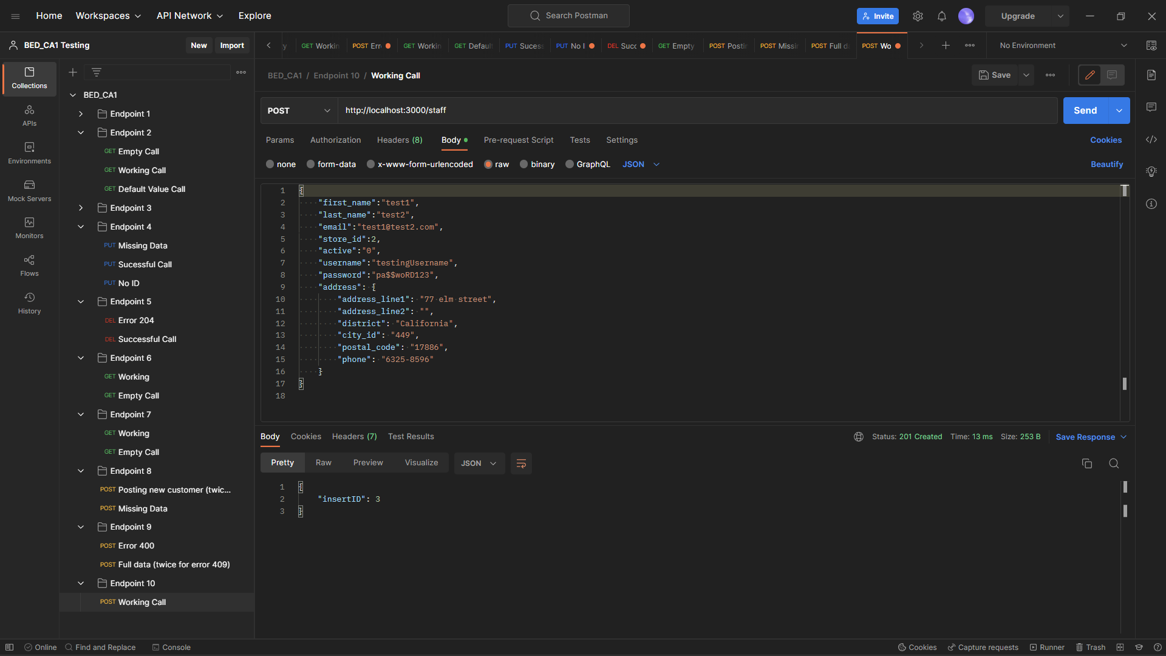

* Duplicate e-mail already in system (Error 409)

* Missing Data (Error 400)

* Server Error (Code 500)

